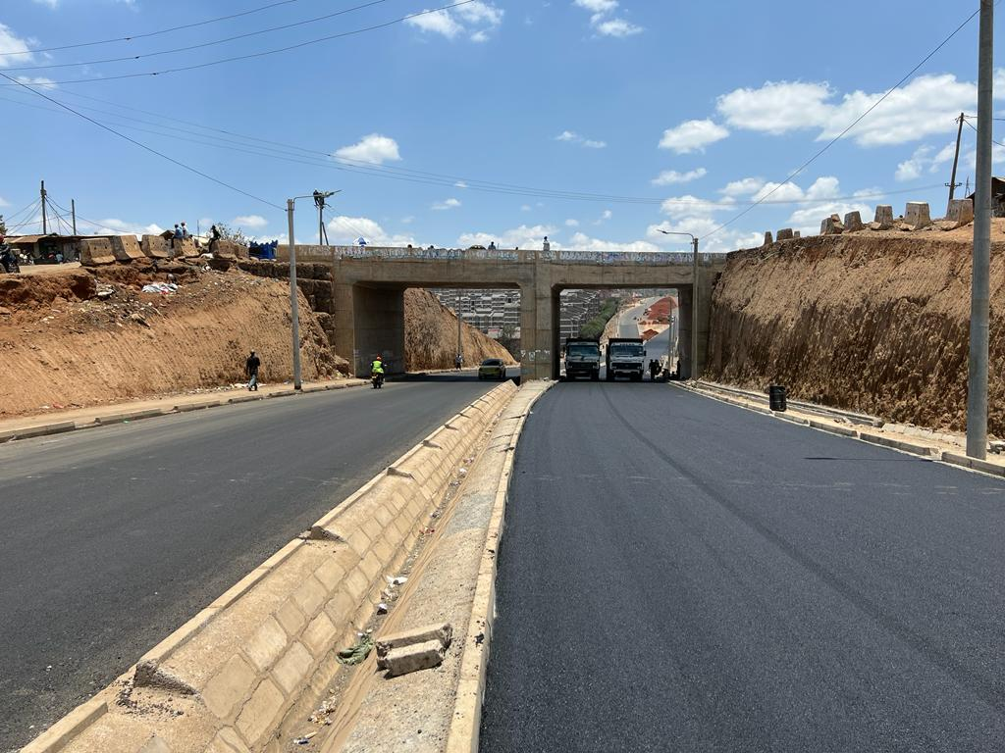

After

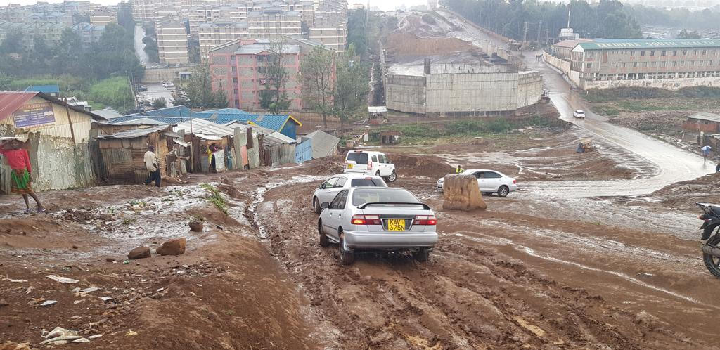

Before

The construction to Bitumen Standard of Missing Link between Kibera and Langata (ML12) has improved the livelihood in the Kibera slum and reduced travel time from Langata to the CBD by half. Initially it used to take up to two hours during peak hours to travel from Langata through the Langata Road to Community and the CBD. With the completion of the Missing Link it now takes less than five minutes to travel from Otiende in Langata to Ngong Road junction. The insecurity within the slum has reduced because of improved lighting as a result of installation of street lighting and increased traffic speeds. The residents do not have to fear heavy rains because the road is all weather and the Mutuini Bridge has high clearance hence there will be no possibility of flooding any more. The road is accessible at all times hence residents of Langata and Kibera can engage in 24 hour economy.